Intelligent Semi-automated Serious Educational Game Generation for the SimSYS Serious Educational Game Development Platform

TR xxxxx

author list

Acknowledgements

xxx.

Abstract

yyy.

Table of Contents

Acknowledgements ii
Abstract iii
Table of Contents iv
1. Introduction 1
2. Related Work 2
2.1 Introduction 2
2.2 Code Generation 2
2.2.1 subheading 2
2.2.2 subheading 2
2.3 Automation in e-learning, games, serious educational games 2
2.3.1 subheading 2
2.3.2 subheading 2
2.4 Conclusions 2
3. Your solution 3
3.1 Introduction 3
3.2 Detailed description 3
3.2.1 subheading 3
3.2.2 subheading 3
3.3 Tool Support 3
3.3.1 subheading 3
3.4 Validation results 3
3.4.1 subheading 3
3.4.2 subheading 3
3.5 Conclusions 3
4. Conclusions and Future Work 4
4.1 subheading 4
4.1.1 subheading 4
4.1.2 subheading 4
4.2 subheading 4
4.2.1 subheading 4
4.2.2 subheading 4
5. References 5
Appendix A. title here 6

Introduction

// a place to start is one paragraph for each of these:

Intro. to changing educational needs, how e-learning fits into that shift (include definition with reference for e-learning)
Intro. to serious educational games (include definition with reference of serious educational game)
Intro. to automation in serious education games (what other researchers have automated)
Intro. to the SimSYS Game Development Platform (overview, with references)
Focus in on the intelligent semi-automated game generation component
Why is this research needed?
Brief overview of the component, research methodology (including validation), and results
Structure of this report

Related Work

Introduction

In empirical comparisons of Aspect-Oriented (AO) to ObjectOriented (OO) systems, system properties such as understandability, maintainability, reusability, and testability have often been inferred from other metrics, such as lines of code, sites of change, and modularity. However, in traditional OO metrics suites such system properties are assessed separately from these measures. We applied OO metrics for comparing an AO with an OO system and found that improved modularity did not imply improvements in the system properties listed above.
This paper illustrates the appropriateness of using OO metrics for the empirical analysis of systems, and presents evidence that in subsequent studies of AO systems certain system properties should be assessed separately from modularity. Also we compare these two approaches in two different systems called recommender system and real-time system, check the Optimality in their performance.

Automation in Java-based Real-time Systems

When designing and building systems, it is often difficult to arrive at a design that modularises all required system features. More often than not, there are certain features that will not fit well into any class structure we choose. This is particularly true for certain kinds of functionality, such as logging, debugging or handling of real-time constraints. Design compromises often lead to code that is “tangled” and “scattered”. If two features are tangled, their code is intertwined, and difficult to separate. If a feature is scattered, it means that code related to it appears around the system. Tangling and scattering are summed up in the term “crosscutting”, and hurt certain system properties such as understandability, maintainability, testability, and reusability of our systems.
To conduct our experiment, we constructed aspectand object-oriented real-time sentient traffic simulators. We called these AOSim (Aspect-Orientation) and OOSim (Object-Oriented) respectively. We initially constructed OOSim by evolving an existing sentient traffic simulator to include real-time considerations. We identified realtime code in OOSim and encapsulated it into aspects in AOSim. This section describes the original simulator, outlines the design of OOSim and AOSim, and provides implementation details of both simulators.

Original Design:
The Sentient Traffic Simulator was developed independently by the Distributed Systems Group in Trinity College Dublin. The simulator models a traffic management system that allows vehicles to self-drive along a stretch of four-lane highway. Vehicles are equipped with sensors that allow them to determine speed and positioning information about vehicles surrounding them. Vehicles react to their sensor information: a vehicle must allow emergency vehicles to pass and must reduce speed if approaching a slower moving vehicle.
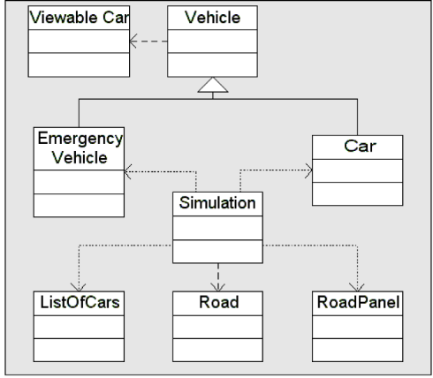
Figure 1: Sentient Traffic Simulator Class Structure

We chose the simulator as the base system for our experiment because it strongly requires real-time functionality to properly model a traffic system. In particular, scheduling and timing are of critical importance, because a vehicle needs the ability to react to any unexpected events in its environment in a timely and controlled manner.

Aspect-Oriented Programming for Java-based Real-time Systems
To construct OOSim, we identified where real-time behaviour was required in the original simulator, and implemented that behaviour using RTJava. In some cases we replaced functionality, while in others we added new functionality.
We examined functionality such as allowing emergency vehicles to pass, or slowing down, to assess where unpredictable delays occur, and where external events should be catered for. Unpredictable delays occurred in the way threads where handled, and also where objects were allocated to memory and became subject to garbage collection. We re-implemented this functionality using RTJava constructs.

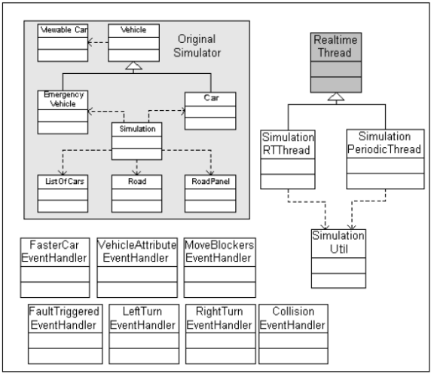
Figure 2: Sentient Traffic Simulator Class Structure with RTJava Constructs

Figure 2 illustrates the class structure of the Simulator that uses RTJava. A number of asynchronous event handler classes were added that are responsible for handling asynchronous events. SimulationUtil provides utility functions related to RTJava constructs. Two RealtimeThread subclasses, SimulationRTThread and SimulationPeriodicThread shown in Figure 2, were implemented which provide specific real-time threading behaviour required for the Simulator. Class RealtimeThread is shown in grey since it is part of the RTJava API.

Object Oriented Programming for Java-based Real-time Systems
The aspect-oriented version of the Simulator (AOSim) was constructed by re-engineering OOSim.For each real-time area, we identified RTJava code that appeared in OOSim. We encapsulated this code into aspects, with one aspect for each real-time area.
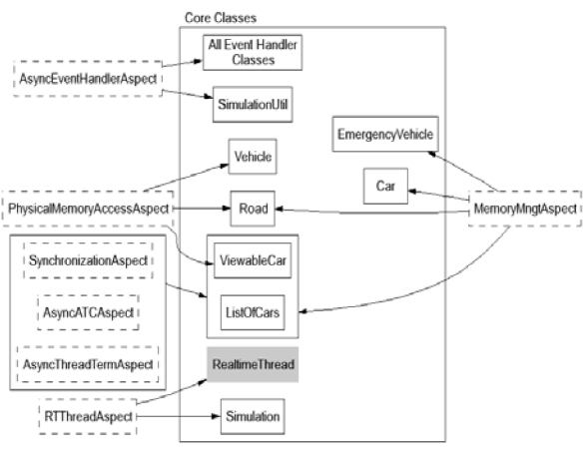
Figure 3: Simulator Aspects and Relationships

Dashed-boxes in Figure 3 depict the aspects used. There is one aspect for each real-time area. Arrows show the core classes into which aspect-code is woven. For example, the MemoryManagement aspect encapsulates crosscutting code for the EmergencyVehicle, Car, Road,ViewableCar and ListofCars classes. Once again, class RealtimeThread is shown in grey since it is part of the RTJava API.

- Real-time Threading aspect: encapsulates the creation of real-time threads through subclassing and the starting of real-time threads
- Memory Management aspect: encapsulates the creation of objects that are not subject to garbage collection
- Synchronization and Resource Sharing aspect: encapsulates the waiting, locking, and notifying of objects
- Asynchronous Event Handling aspect: encapsulates the binding of asynchronous event handlers to events, the firing of asynchronous events, and the declaring of AsyncEventHandler parent by asynchronous event handler subclasses
- Asynchronous Transfer of Control (ATC) aspect: encapsulates the throwing and handling of AsynchronouslyInterruptedException, the handling of interruptible code, and the firing of interrupts
- Asynchronous Thread Termination aspect: as with ATC
- Physical Memory Access aspect: encapsulates the handling of exceptions thrown when accessing physical memory In AOSim, the locations of crosscutting code became joinpoints and we specified pointcuts to replace their functionality through weaving.

2.2.3. Change in Individual Results due to Use of Aspects
This section provides the results for the comparison of OOSim and AOSim. We used the C&K metrics suite in our evaluation because it provides the most comprehensive and best validated set of measures . We adapted the calculation of each metric for use with aspects. The application of the C&K suite involves measurement against several metrics, including number of children, and number of methods per class. These individual results are then used in combination to assess system properties, such as testability and maintainability.

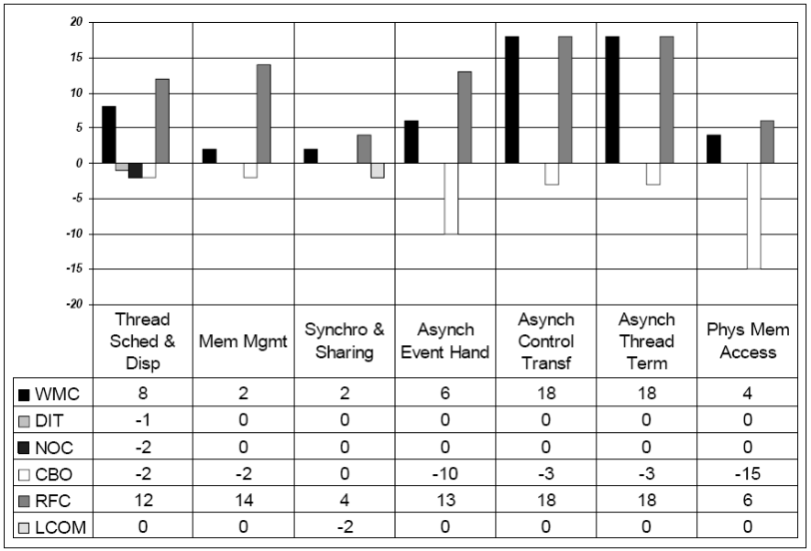
Figure 4: Change in Individual Results due to Use of Aspects

For each metric we describe how it is calculated, and its individual results, in terms of the change in value from OOSim to AOSim. These values are summarised in Figure 4. We then describe the metrics’ combined effect on system properties. Finally, we discuss factors affecting the results.

Automation in Recommender System
Recommender system is a technological proxy used for searching out a good option amongst a potentially overwhelming set of alternative products or services. A recommender system recommends items to users by predicting items relevant to the user, based on user profile which contains various kinds of information including items, user information and interactions between users and items . Recommender systems use the opinions of members of a community to help individuals in that community, by identifying information most likely to be interesting to them or relevant to their needs.
These systems form a specific type of information filtering technique that attempts to present information items such as movies, music, books, news, images, web pages, that are most likely to be of interest to the user. These systems are very powerful cognitive decision-makers in the context of distributed online information processing in real-time networked scenarios .
Recommender Systems have come up in the market to advice users so that the right information is delivered to the right person at the right time. These systems can be classified mainly into four categories: content based, collaborative filtering based, knowledge based and hybrid recommender systems.
- Content based recommender systems use the ratings of the items the target user liked in the past to predict items the target user would also like.
- Collaborative filtering based recommender systems use the ratings of the users with tastes “similar” to the target user and predict items for the target user.
- Knowledge based recommender systems use a knowledge structure to make inferences about the user needs and preferences.
- Hybrid recommender systems use a combination of the above approaches.

The OOWS Navigational Model
OOWS (Object-Oriented Web Solution) is a Model-Driven development process of Web applications which proposes an automatic code generation strategy from a set of highly descriptive, UML-compliant conceptual models.
The OOWS Navigational Model provides developers with conceptual primitives to model the navigational characteristics of a Web application. This is made from two perspectives: (a) the modelling of the global structure of the application, by means of a set of navigational maps that describe the navigational topology of the application in terms of its nodes (navigational contexts) and links; and (b) the modelling of the inner navigational structure, in terms of the data, operations and hyperlinks that can be accessed in each context, which are defined as views of the domain description (a UML Class Diagram).
Navigational Contexts represent interaction points that provide users with access to data and operations, through the aggregation of one or more navigational views of the Class Diagram. These views are called Abstract Information Units (AIU). Each AIU is composed of one or more Navigational Classes which are related through Navigational Relationships. Both structures are navigational views of classes and associations from the Class Diagram of the application, respectively. The navigational class that provides the main information of the AIU is called manager class, while those that provide complementary information are called complementary classes.
When a navigational relationship is crossed, the information of the selected object is carried to a target context. According to their dependence of this information, OOWS distinguishes two types of AIUs: (a) Contextual AIU (labelled with a circled “C” tag), which instantiates its manager class to the object received as contextual information; and (b) Non-Contextual AIU (labelled with a circled “NC” tag), which does not depend on the contextual information received by its containing context. Finally, two structures can be defined in any navigational class: Population Filter, which constrains the objects that are shown to users; and Ordering Pattern, which defines an order of presentation of the retrieved objects. Both filter constraints and ordering criteria are expressed through OCL expressions.

Modelling Web-based Recommender Systems
The present proposal describes a basic but frequent scenario of implementation of recommendation techniques in e-commerce applications. This scenario considers the presentation of a list of recommended items, which are selected and ordered according to the predicted relevance that each of them has for the active user. Each item of this list contains a link that leads to a page that provides detailed information about the selected item, along with a list of similar items that may be of interest for the active user. Furthermore, this page may also provide mechanisms that allow users to rate the presented item. In order to answer these requirements, the system must consider the following aspects: (a) means to measure the interest or preference of users for the different catalog items of the application; (b) an algorithm that calculates the similarity between the catalog items, based on the ratings submitted by users; and (c) an algorithm that predicts the rating that a given customer would give to a candidate item, based
on the obtained similarity of this item with those preferred by this user.

Conceptual Modelling Proposal
Unlike many data-intensive e-commerce applications, in which business logic layer is mainly focused on the management of database queries, recommender systems demand an special consideration of this layer, due to the incorporation of rating mechanisms and recommendation techniques. This complexity makes the
Object-Oriented paradigm a suitable approach to develop this kind of systems, due to its natural anagement of data and methods, along with the decomposition mechanisms that help to break such complex algorithms into small, more manageable pieces. The specification of the aspects of each layer is performed by using the following models from the OOWS method:

1. Class Diagram (Persistence Layer)
2. Interaction Diagram (Business Logic Layer)
3. OOWS NavigationalModel (Interface Layer)

Class diagram
The main concepts involved in the process of recommendation are specified through the Class Diagram shown in Fig. 5. The modelled concepts are domainindependent, and its classes may be renamed and complemented according to the requirements of specific application domains. The defined classes are:
- CATALOGUE: it represents a catalogue of information items. One application can provide users with different catalogues (e.g., a store that offers one catalogue of books and other of CD’s);
- ITEM: it models the information items to be evaluated by and recommended to different users. Each object of this class contains a preference vector, which is a string of length m, that represents the preferences of each of the m registered users for the corresponding item. This vector may contain unary values (representing only positive preferences), binary values (positive and negative preferences), or integer values (rating of an item).
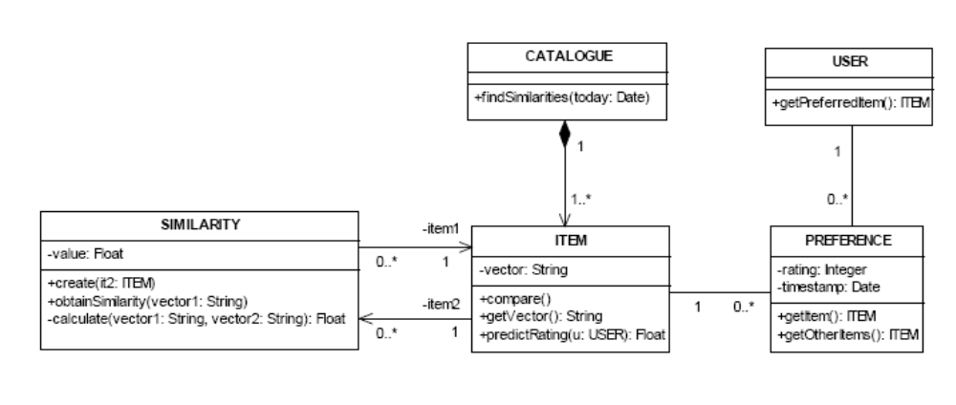
Fig. 5. Class diagram of a generic recommender system.

- USER: it represents the registered users of the application, which receive recommendations from the system.
- PREFERENCE: it describes the explicit of implicit action of marking an item as preferred by a registered user. For instance, it may describe the purchase of a product, the rating of an article (explicit actions), or the visit of the page that give details about a product (implicit action). It includes an optional rating attribute, which represents the evaluation of the item by the associated user; and a timestamp attribute, which describes the time in which the preference has been marked.
- SIMILARITY: it represents the similarity between two information items. Its private method calculate implements a similarity algorithm, which compares the rating vectors of the two item objects, obtaining a similarity value that is used to select and sort the recommended items.

OOWS Navigational Schema
Finally, the navigational schema of the two pages from the described scenario is defined. Figure 6 shows the inner structure of both pages, which are modeled through respective OOWS navigational contexts. The left context shows a navigational class, which is a view of the ITEM class, including the attributes and
operations that are visible to the user. A navigational relationship leads users to another page, where detailed information on the selected item is provided. Furthermore, it contains a population filter (bottom of the class) and an ordering pattern (top tag), which filter and order the recommended items according to the fulfilment of OCL constraints, respectively. For visibility purposes, these constraints are detailed next.
The following OCL expression corresponds to Adaptive Population Filter 1. The invariant of this filter uses the predictRating() operation described through the communication diagram of Fig. 6, and specifies the condition that must be fulfilled by self object to be included into the recommended items.
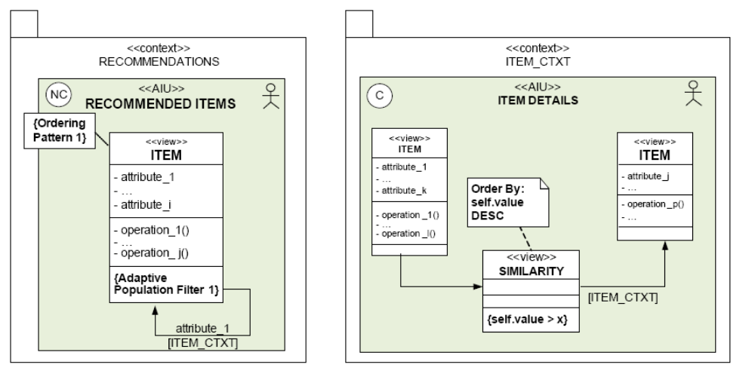
Fig. 6. OOWS navigational schema of a typical recommendation system.

The OCL expression of Ordering Pattern 1 is a query that returns the predicted rating value obtained from the predictRating() operation. In this way, the list of recommended items is ordered according to their respective predicted rating.

context ITEM::query_order(): Real
let currentUser: USER = system.currentUser()
in self.predictRating(currentUser)

The right context of Fig. 6 represents the page of a selected item, which also includes another list of recommended items that are similar to the currently displayed. It contains a contextual AIU that uses the information selected in the previous context (page) to determine the object whose information is shown. To display the recommended related items, the system retrieves a subset of comparisons whose similarity values are bigger than an x, which is represented by a SIMILARITY complementary class whose objects are constrained by a population filter and sorted by a ordering pattern. Associated to each similarity object, the recommended items are displayed, through the ITEM complementary class.

Proposed Aspect-oriented Trust Based Mobile Recommender System
Aspect Oriented Programming (AOP) is a programming paradigm which aims to improve modularity of the software systems by allowing separation of crosscutting concerns. Crosscutting concerns usually refer to non functional properties of software such as learning, security, transaction management, synchronization, mobility, and error handling. Implementation of crosscutting concerns in a recommender system by using a conventional agent oriented approach leads to a problem of code scattering and code tangling .
Scattering in agent-oriented models is the manifestation of design elements that belong to one specific concern, over several modeling units referred to other MAS concerns. Tangling in agent-oriented models is the mix of multiple concerns together in the same modeling elements. Using AOP, these problems can be efficiently solved since AOP gives the more flexibility to implement these concerns by integrating the aspects with the base code without changing the existing code. AOP has various constructs such as: Joinpoint, Pointcut, Advice and Aspect.
- A joinpoint is a well-defined point in the code at which the concerns crosscut the application such as method call, object construction, or field access.
- A pointcut defines the times (joinpoint) in the application at which cross-cutting concern needs to be applied.
- An advice is a code fragment that is executed when join points satisfying its pointcut are reached. This execution can be done before, after, or around a specific join point.
- An aspect is a basic unit of modularization for crosscutting concern that cuts across multiple objects.

Architecture of the AOTMRS
AOTMRS (Aspect-oriented Trust Based Mobile Recommender System) automates the process of finding the appropriate places for the mobile user according to his demographic information. The basic building blocks of this system are shown in figure 7. On the client side, two components are active.
The first is the normal off-the-shelf Internet browser and it is the only component that the user sees on the mobile screen during usual operation. Using this component only, the mobile user can interact with the recommendation system. The second component is the location detection that periodically sends the information about the mobile user such as his current location, time etc. to the mobility aspect at the server.
This module is generally transparent to the mobile user. It will only display a startup dialog box for initialization purpose, for example to change the privacy settings or allowing the application to detect the mobile location. Location dealer component of the server also contains two sub components: (i) mobility aspect and (ii) trust based recommendation system.
The mobility aspect is in-charge of computing the location data i.e. transmitted by the location detection component of the client in order to obtain a good estimate of the user location (due to the power and computation capability limitations, it may be impractical for the mobile to compute the precise location, and only raw data are transmitted to the server) and to track the user’s movements. The second sub component of location dealer, the trust based recommendation system is the core of the system: it maintains the access database and generates the recommendations for the user. Figure 7 shows the architecture diagram of AOTMRS.

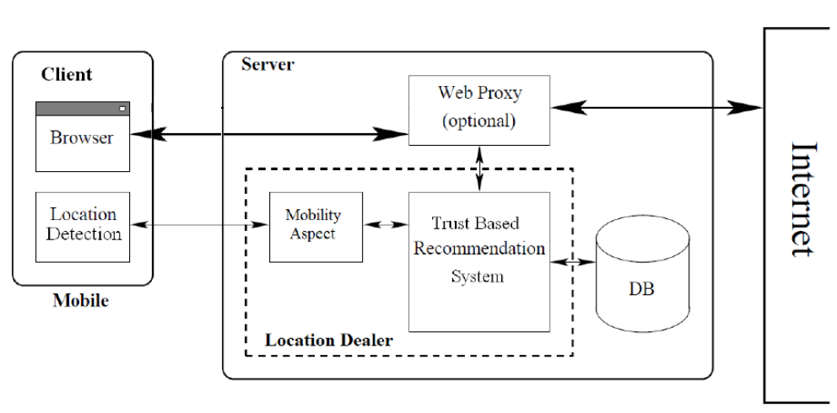
Figure 7: Architecture of the AOTMRS System

Enhanced Trust Based Multi-Agent Recommender System with Aspect Oriented Approach
Mobility aspect is created and integrated with various agents’ goals of trust based multi-agent recommender system at well defined join points with point cuts to improve the separation between the mobility concern and other agent concerns. The mobility aspect connects the execution points (events) on different agent classes in order to change their normal execution to handle mobility crosscutting concerns.
The execution points include the execution of actions on plans, and agent types. Mobility aspect eliminates the problem of tangling and scattering from the trust based multi-agent recommender system easily because it provides better modular support for the separation of crosscutting concerns. If some mobility strategy changes later on, even then these can be easily handled by modifying this mobility aspect without changing the existing code of the recommender system. Hence our approach reduces the cognitive complexity and provides better modular way to design a multi-agent recommender system.

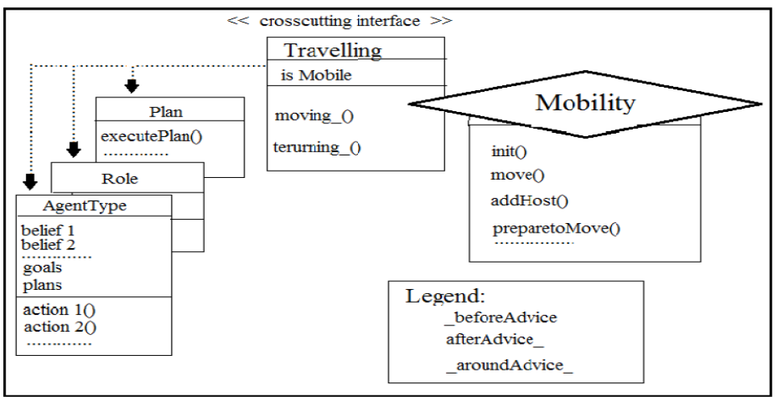
Figure 8: The static view of the Mobility aspect

Mobility aspect defines how and when the agents will move to other environments. The mobility aspect itself invokes the methods responsible for implementing the mobility-specific actions, such as identifying user position, move () and return Home () etc. No mobility code remains in the agent classes that implement the basic functionality and collaborative activities. Figure 8 represents static view of the mobility aspect of trust based multi-agent recommender system.

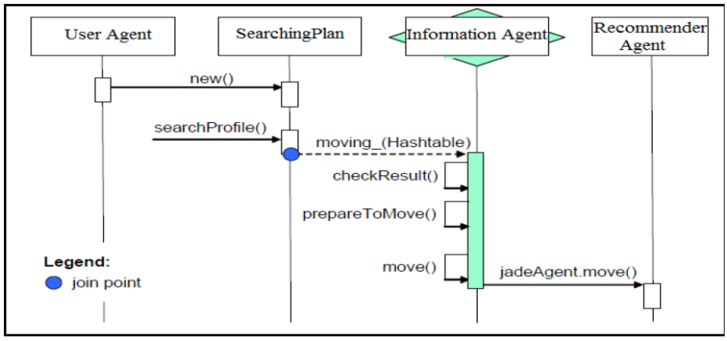
Figure 9: Dynamic behaviour of the Mobility aspect

Figure 9 illustrates the dynamic behavior of the mobility aspect. The scenario shows that how the mobility aspect move agents and roles in a transparent way.

List of Comparison criteria’s:
This survey paper compares two different automated generation method called aspect-oriented and object-oriented in recommender systems and real-time systems via below comparison criteria’s.

Comparison Criteria’s:

- Usability: Software can be used easily by users
- Maintainability: Software can be restored to a specified condition within a specified period of time
- Reusability: Software is able to add further features and modification with slight or no modification.
- Testability: is the degree to which a software system, supports testing in a given test context.
- Optimality: System suggests to users few recommendations about the issues they are looking for, in order to save and optimize their time and energy due to problem of information overload.

 | Real-time System |  | Recommender System
 | Aspect-Oriented | Object - Oriented | Aspect-Oriented | Object - Oriented
- Usability

- Maintainability

- Reusability
- Testability

- Optimality

Table 1 : Comparison table

Your solution

Introduction
// introduction for this section

Overview figure, architecture with description (inputs, processing, outputs)
Describe in terms of the comparison criteria

Detailed description
xxx

subheading
xxx

subheading
xxx

Tool Support

subheading

Validation results
xxx

subheading
xxx

subheading
xxx

Conclusions
// conclusions for this section

Conclusions and Future Work

subheading
xxx

subheading
xxx

subheading
xxx

subheading
xxx

subheading
xxx

subheading
xxx

References
// use correct format for book, journal, conference paper
// avoid websites

- C. Shaun Longstreet, Kendra Cooper, A Meta-model for Developing Simulation Games in Higher Education and Professional Development Training, IEEE 17th International Conference on Computer Games, Kentucky, USA ,2012
- S. Tang, M. Hanneghan, A Model-Driven Framework to Support Development of Serious Games for Game-based Learning, School of Computing and Mathematical Sciences, Liverpool John Moores University, UNITED KINGDOM, 2010 Developments in E-systems Engineering, IEEE Computer Society, 2010 .
- Cheng-ping Chen, Ju-ling Shih, A Prototype on a Meta-model for Designing Instructional Pervasive Games, Department of Information and Learning Technology, National University of Tainan, 2012 Fourth IEEE International Conference On Digital Game And Intelligent Toy Enhanced Learning, 2012.
- Sara de Freitas, Learning in Immersive Worlds: A review of game-based learning, Prepared for the JISC e-Learning Programme.
- Jeannette Bennett, Kendra Cooper, Lirong Dai, Aspect-oriented model-driven skeleton code generation: A graph-based transformation approach, Science of Computer Programming 75, pp: 689_725, 2010.
- Antti Kirjavainen, Development of Game-Based Learning Environments – Constructing a Quality Multi-Disciplinary Development Process, University of Jyvaskyla, Department of Mathematical Information Technology & Agora Center, Dissertation in Information Technology, October 6, 2009.
- Masoud Hemmasi, Lee A. Graf, Illinois State University, EDUCATIONAL EFFECTIVENESS OF BUSINESS SIMULATION GAMING:A COMPARATIVE STUDY OF STUDENT AND PRACTITIONER PERSPECTIVES, Development In Business Simulation & Experiential Exercises, Volume 18, 1991.
- S. Tang, M. Hanneghan, Fusing Games Technology and Pedagogy for Games-Based Learning Through a Model Driven Approach, School of Computing and Mathematical Sciences, Liverpool John Moores University, Liverpool, UNITED KINGDOM, 2011 IEEE Colloquium on Humanities, Science and Engineering Research (CHUSER 2011), Dec 5-6, Penang, 2011.
- Nathan Balasubramanian,Brent G. Wilson, GAMES AND SIMULATIONS, Society for Information Technology and Teacher Education (SITE), 2005.
- Tsung-Li Wang, Ya Fen Tseng, Learning Effect for Students with Game-based Learning on Meta-Analysis, The 6th International Conference on Computer Science & Education (ICCSE 2011), pp. 1291-1295, August 3-5, 2011. SuperStar Virgo, Singapore, 2011.
- Javier Torrente, Pablo Moreno-Ger, Baltasar Fernández-Manjón (2008). Learning Models for the Integration of Adaptive Educational Games in Virtual Learning Environments. Proceedings of the 3rd International Conference on E-learning and Games (Edutainment 2008), Nanjing, China. Lecture Notes in Computer Science 5093, pp. 463–474.
- Miroslav Minović, Miloš Milovanović, Mladjan Jovanović, Dušan Starčević, Model Driven Development of User Interfaces for Educational Game, HSI 2009 Catania, Italy, May 21-23, 2009
- Lina Marcela Morales, David Mendez-Acuna, Willy Montes, Model Driven Game Development - Case Study A MTC for maze game prototyping Departamento de Ingeniera de Sistemas y Computacion, Universidad de los Andes, Colombia.
- Marcio de O. Barros, Alexandre R. Dantas, Gustavo O. Veronese, Claudia M. L.Werner, Model-driven Game Development: Experience and Model Enhancements in Software Project Management Education, Softw. Process Improve. Pract. pp. 411–421. 2006.
- Miroslav Minovic, Milos Milovanovic, Dusan Starcevic, Modelling Knowledge and Game Based Learning: Model Driven Approach, Journal of Universal Computer Science, vol. 17, no. 9 pp. 1241-1260. 2011.
- Diana Oblinger, Simulations, Games, and Learning, EDUCAUSE, May 2006.
- STEPHEN TANG, Martin Hanneghan, State of the Art Model Driven Game Development: A Survey of Technological Solutions for Game-Based Learning, Journal of Interactive Learning Research (201 1) 22(4), pp: 551 -606.
- Josephine M. Randel, Barbara A. Morris, C. Douglas Wetzel and Betty V.Whitehill, The Effectiveness of Games for Educational Purposes: A Review of Recent Research, Simulation & Gaming, 1991.
- Kendra Cooper, C. Shaun Longstreet, Towards Model-driven Game Engineering for Serious Educational Games: Tailored Use Cases for Game Requirements, IEEE 17th International Conference on Computer Games, Kentucky, USA ,2012.

Appendix A. title here

